|  |  |
| --- | --- |
| Name: |  |
| Lab User ID: |  |
| Date: |  |
| Application Name: |  |

**Follow the below guidelines:**

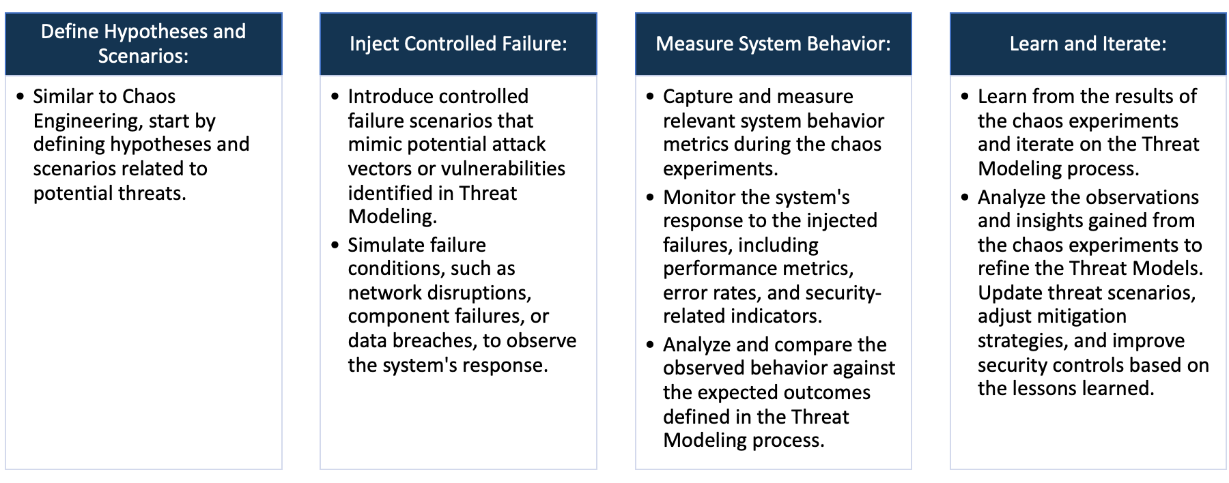

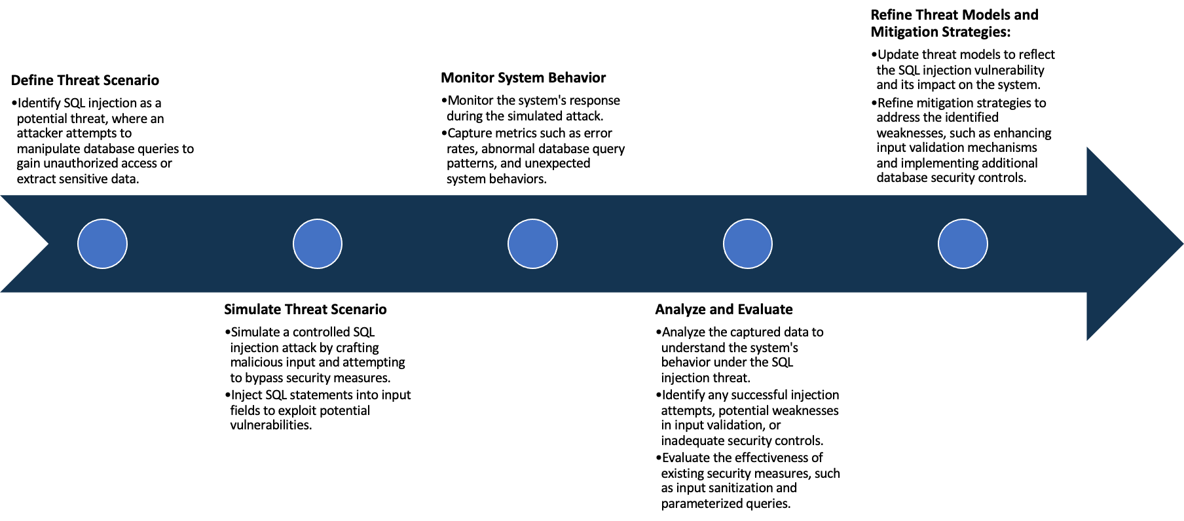

System Architecture:

(Understand the system and document the physical and logical architecture of the system, use the shapes and icons to capture the system architecture)

Define system’s normal behavior:

(Define the steady state of the system is defined, thereby defining some measurable outputs which can indicate the system’s normal behavior)

Hypothesis:

(During an experiment, we need a hypothesis for comparing to a stable control group, and the same applies here too. If there is a reasonable expectation for a particular action according to which we will change the steady state of a system, then the first thing to do is to fix the system so that we accommodate for the action that will potentially have that effect on the system. For eg: "If one of our database servers fails, our service will automatically switch to a backup server, and users will not experience any downtime or data loss.")

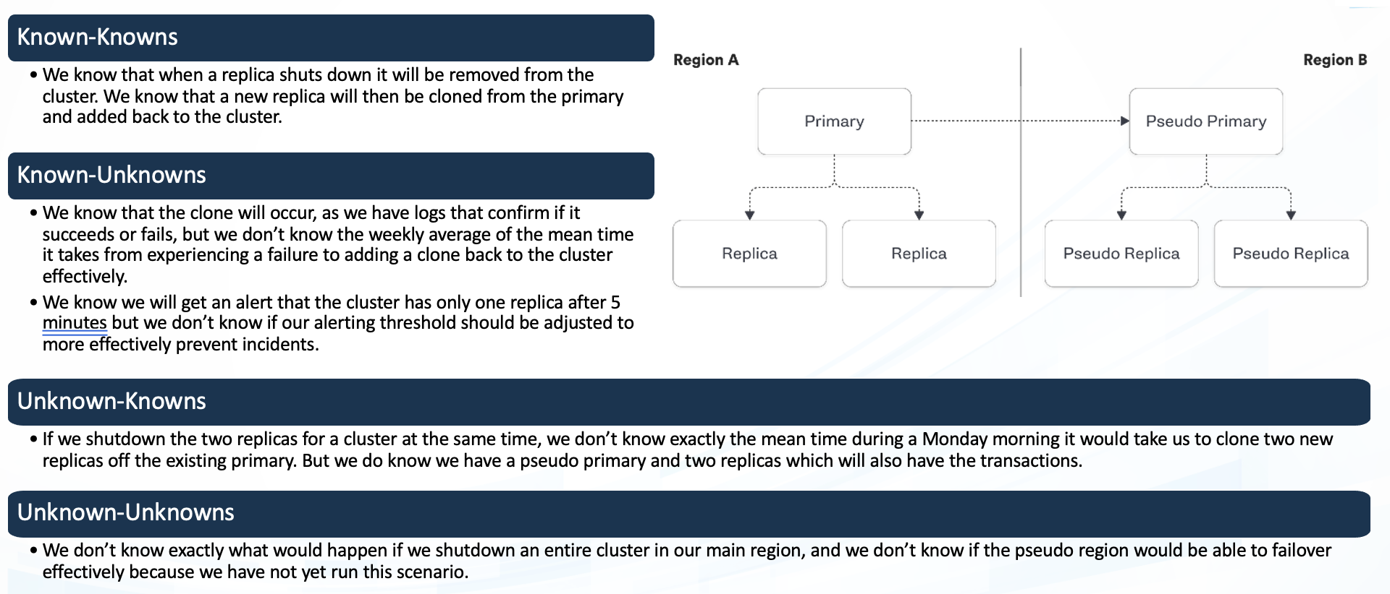

**Known**

Things we are aware of but don’t understand.

Things we are aware of and understand.

942236

**Unknown**

**Unknown**

**Known**

Things we are neither aware of nor understand.

Things we understand but are not aware of.

Experiment:

(Document your Preparation, Implementation, Observation and Analysis )